**Creation of tables**

|  |  |
| --- | --- |
| **Team Id** | **LTVIP2025TMID29041** |
| **Project Name** | Calculating Family Expenses |
| **College Name** | Kandula Lakshumma Memorial College of Engineering for Women |
| **course** | Computer Science Engineering |

**2.Creation of columns (Fields)**

**2.1 Insert values**

* In family expenses table there are columns
* Near columns double click near insert a new row

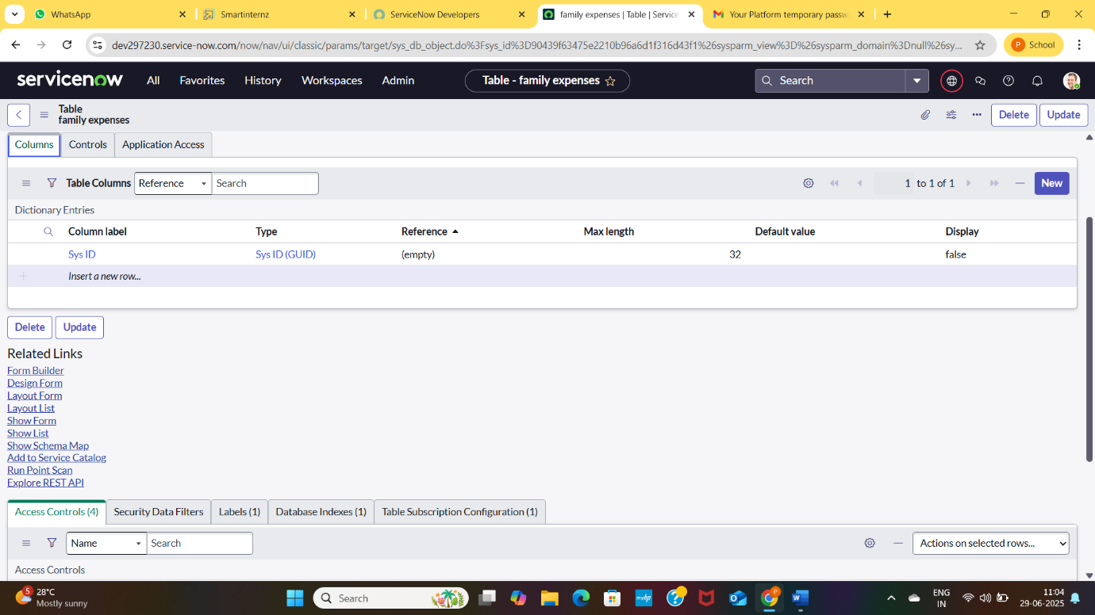

**2.2 Give the details as:**

* Column label: Number
* Type: String

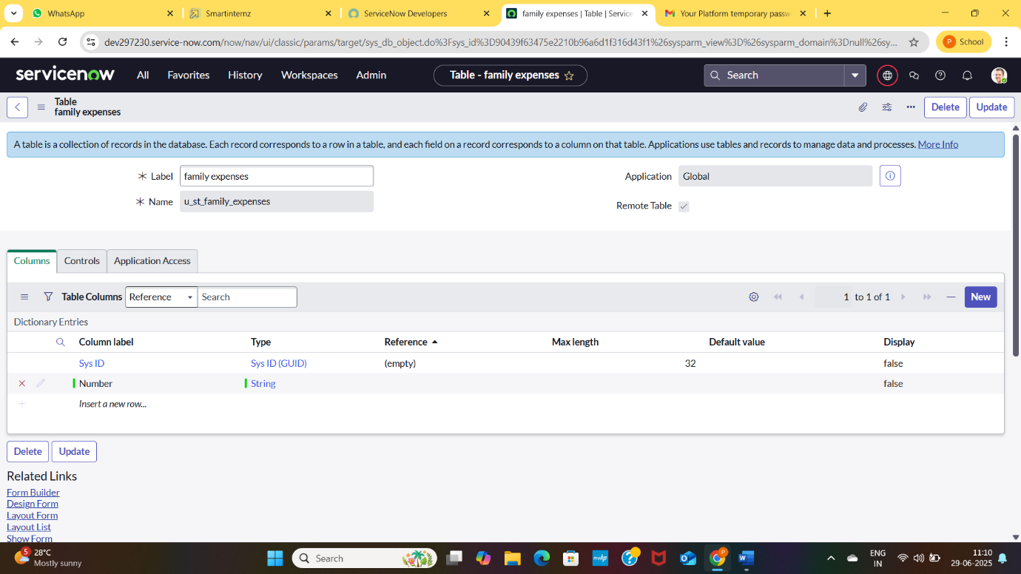

* Double click on insert a new row again
* Give details as:
* Column label: Date
* Type: Date
* Double click on insert a new row again
* Give details as:
* column label: Amount
* Type: Integer
* Double click on insert a new row again
* Give details as:
* Column label: expense details
* Type: String
* Max length: 800

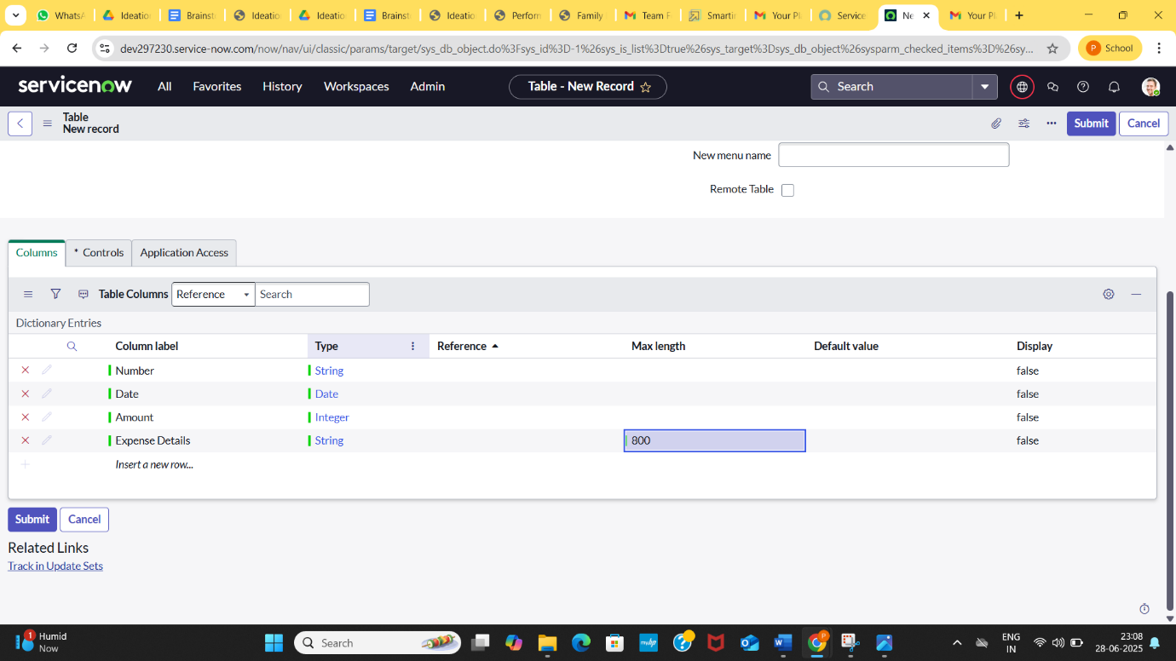

* Go to Header and right click there
* Click on save

